CHEMICAL ENGINEERING TRANSACTIONS  VOL. , 2023 | A publication of
The Italian Association
of Chemical Engineering
Online at www.cetjournal.it

Guest Editors: David Bogle, Flavio Manenti, Piero Salatino
Copyright © 2023, AIDIC Servizi S.r.l.
ISBN 979-12-81206-04-5; ISSN 2283-9216

A Different Approach to the Design of a Rooftop Photovoltaic System.
Girolamo Di Francia
ENEA CR-Portici, P.le E. Fermi 1, 80055 Portici, Italy
girolamo.difrancia@enea.it
The need to accelerate the energy transition has strongly increased the interest towards the installation of photovoltaic arrays on building roofs. At the same time, for reasons mainly related to the deep digital transformation all the world is experiencing, the number of mobile telephony base stations, the antennas, is growing too. As a result, a high number of such installations is expected, particularly in the most highly populated cities just on the same roofs that should be available for photovoltaic plants. Typically, an antenna is expected to interfere with the operation of the photovoltaic system only because of its possible shading effect on the photovoltaic panels, so that, where possible, countermeasures are undertaken by properly designing the PV array. But the interaction can be much more complicated than that. In this work the interaction of a PV plant with a mobile telephony base station is investigated both in terms of the electromagnetic shielding effect that PV panels can operate on the RF waves propagation and in terms of the passive electromagnetic reflective action that the same array can exhibit. It is found that: a) the shielding effect by the PV array can significantly reduce the risk deriving from exposure to the antenna generated em fields that several studies agree now to result in health risks for the populations living in close proximity to the antennas and b) a suitable design of the array and the selection of a proper orientation could help in a better and more uniform propagation of the RF communication signals.

  - Introduction
Pressed by the so-called "fourth industrial revolution", the mobile ICT sector proves deep transformations in data transmission and reception technologies approximately each 10 years. The latest, the set of 5G technologies, has just begun its in-field implementation phase in 2019 and the next one, the 6G technology that is expected to be dominant towards the end of this decade, is now beginning to be tested. Among the various elements that characterize these technologies, the one that probably most characterizes our urban landscape from a physical point of view, especially in large cities, is the continuous growth of mobile transmission stations, the antenna towers. The main reason for that is the growing number of devices that ask to be web connected and, at the same time, the steady increase of the transmission frequencies accessible to those devices.
The 6G scenario will be characterized by devices capable to transmit/receive in the range of hundreds or even thousands of GHz, the so-called millimeter wave range. Such an increase of the transmission frequencies also entails a greater probability that the radio signal is absorbed or dispersed due to the presence of obstacles of various kinds. As a result, to ensure the greatest possible area coverage, the number of antennas is expected to continuously grow with the evolution of the transmission technology. Today the number of antennas in 4G technology is generally proportional to the number of inhabitants (and therefore, to a good approximation, of the devices that need to connect) with a density equal to about 1 station for every 1000-2000 inhabitants. With the 5G technology this number will grow by at least a factor of 10 and a further factor of 10 is expected with the 6G arrival, at the end of the decade. It is thus conceivable that by the end of the decade, each building will either be the site of a mobile station or it will be very close to it, within a few tens of meters at the most. At the same time, the widespread adoption of energy transition policies implies that a large part of those same buildings, probably 1 out of 2 in the EU according to recent studies, will be also characterized by the presence of small photovoltaic (PV) systems, up to a few hundreds of kWp (Solar Power Europe, 2023). Thus the building surfaces, especially in large cities, will end up playing a central role both in the production of clean energy and in supporting and enabling the growing flow of information that characterizes this historical period. Figure 1 shows, as an example, a mobile telephone base station of a 4G network, built in the immediate closeness of a small photovoltaic system installed on the roof of a building placed near the antenna itself.

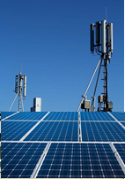

Figure 1: A 4G antenna, built near a small photovoltaic system installed on the roof of a building.

The two worlds, photovoltaic systems and data transmission/reception of electromagnetic (EM) waves in the radiofrequency (RF) range, are essentially considered as separate, except for those applications related to the use of photovoltaic systems to power mobile stations or, vice versa, to the use of 3G or higher technologies, to improve photovoltaic utilities production control. But things aren't always what they seem: between these two worlds there is, already at present, a much more sound interaction. First of all, the possible use of a solar cell as an antenna in the GHz range, has been already investigated in several papers (Baccouch, 2019). Hereafter two further interactions between a photovoltaic array and a RF transmission system are reported. Since from the point of view of RF transmission, a photovoltaic system behaves like a conductor as wide as even several sqmt, a conductor of this size, placed next to a RF source, can significantly modify the electromagnetic waves propagation, giving rise to an interaction that can be used either in terms of shielding from the EM field and as passive RF reflector. Especially the former application could be interesting for roof or facades PV deployment because the shielding effect could significantly reduce the risk deriving from exposure to the EM fields that several studies agree now to result in sensible health risks for the populations living in close proximity to the antennas (Balmori, 2022). This work is divided into 5 sections. In addition to this introduction, in section 2, the way a photovoltaic array interacts with external EM fields is discussed; in section 3, the results of measurements carried out to evaluate this effect in a test site, using a small photovoltaic array, are reported; in section 4, the results of the measurements and the possible applications of this interaction will be discussed, in particular in the design of small photovoltaic plants; finally, in section 5, the conclusions will be reported.

  - A photovoltaic module in a RF electromagnetic field
Currently the most widespread photovoltaic technology is based on crystalline silicon solar cells. Figure 2 shows the basic element of this technology. It is substantially a thin silicon plate with a shape close to a square and with an area up to 156 cm², enclosed between two electrical contacts, the front one, a very fine metallic grid so as to minimally hinder the absorption of solar radiation and the rear one, made instead, in general of a more continuous deposition of an aluminum layer with a thickness of the order of a micrometer. For the sake of completeness it is worth to note here that different device designs are nowadays commercially available where, for instance, a metallic grid takes the place of the continuous back contact.

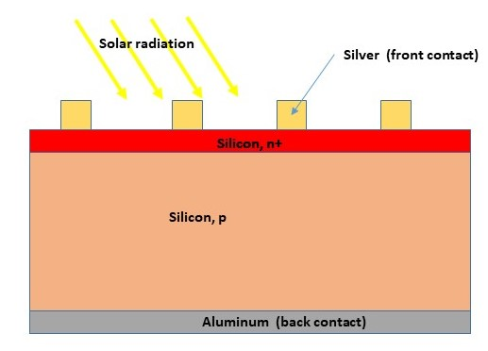
Figure 2: Basic structure of a crystalline silicon solar cell. n+ and p denote adding to silicon Phosphorous (n) and Boron (p) atoms, respectively.

A typical solar panel is made up of sets of solar cells connected in series or parallel so as to obtain the expected electrical rating data (output voltage and current). In the case of parallel connection, the single cell back contacts that make up the module are directly connected each other and the photovoltaic module can be seen, for the purpose of this work, as a single conducting plate with an area almost equal to the entire module area. In the case of series connection, the overall impedance is given by the sum of the individual cell impedances. Since the cell impedance at the frequencies of interest for this work is only resistive and it is not different from the resistance of the aluminum back contact, again, from the point of view of the RF propagation, cells in series, will still appear as a single conductor (Namin, 2013). As it is known, the reflectance of EM waves from metal reflectors is always close to 1, even if it slightly decreases as the frequency increases (Born, 1959). It is worth to note that since the separation between the cells is generally reduced to the minimum so as to minimize the loss of the available incident radiation, this separation may be in fact considered as practically trifling for the shielding properties here considered.

  - Measurements
Figures 3a show the experimental setup used in this work.
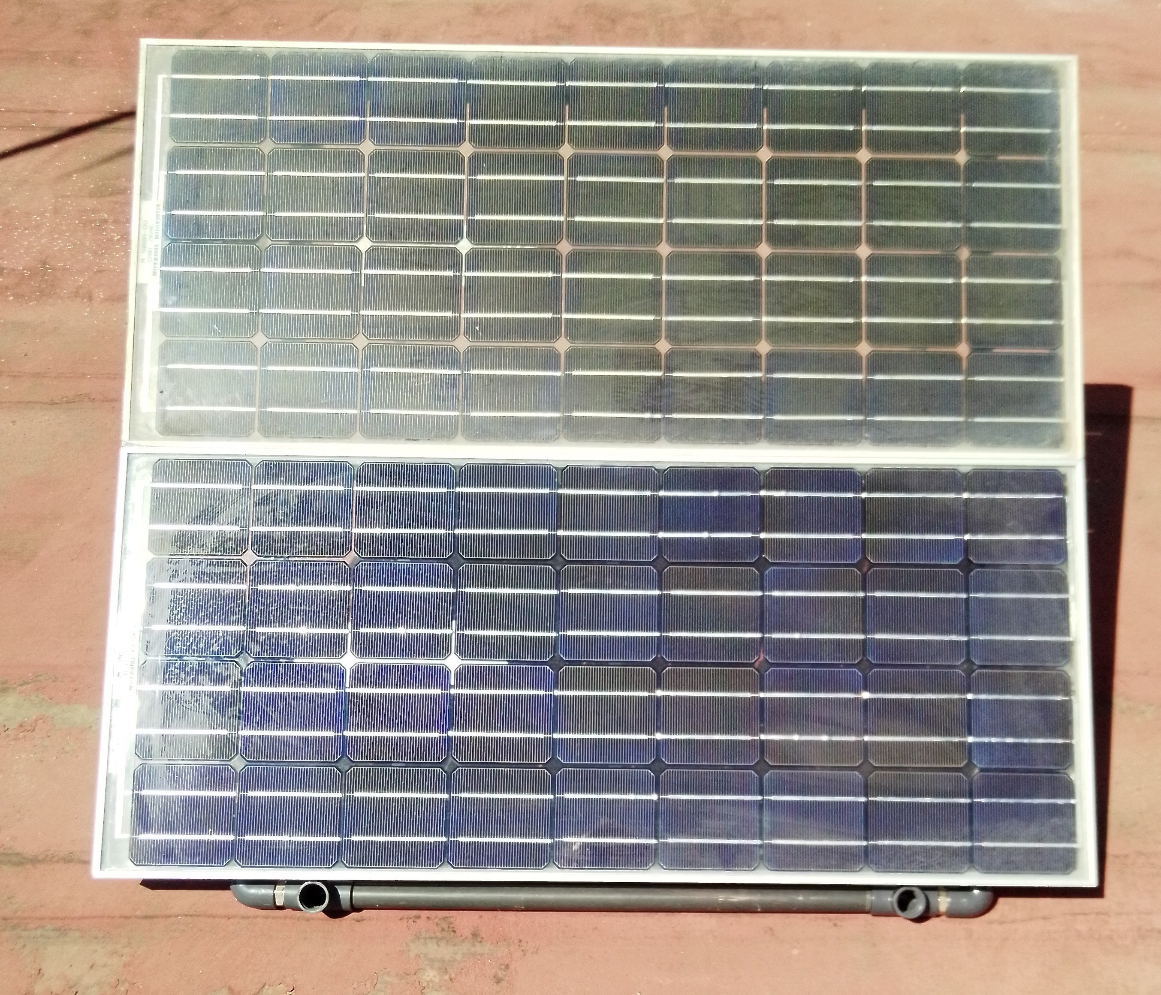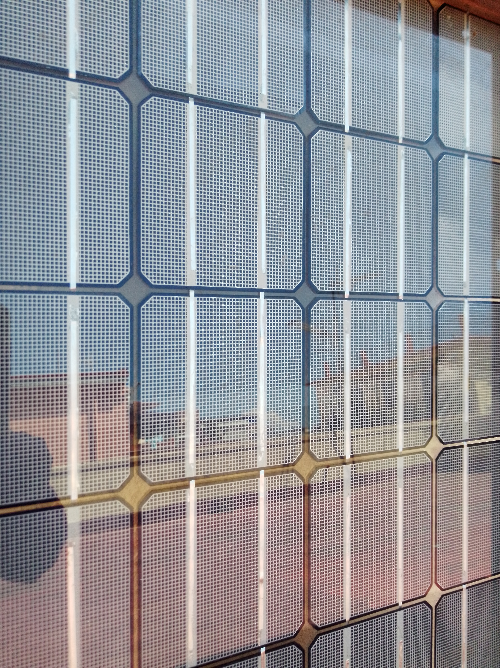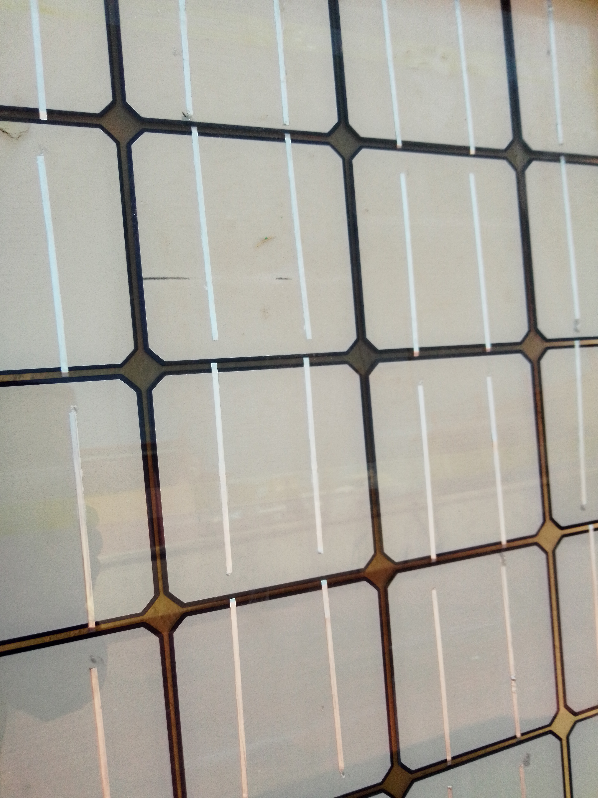
- (b)
Figure 3a: The array of solar modules used as a test installation for this experiment and in Figure 3b a particular of the backside of the modules is shown.

A small array consisting of two glass-glass photovoltaic modules of about 70W each, was set up on a roof of a building located near a mobile antenna station in Napoli, Italy. The two modules used for this work consist of the same type of 100 cm² solar cells except for the backside that, for one of the modules is an Aluminum grid covering an area of about 30% of the cell and, for the other module, it is a continuous Aluminum layer, as it is shown in Figure 3b. For the purposes of this work, the array was oriented towards the antenna with a 35° tilt angle, as it is shown in Figure 4a. In Figure 4b, a schematic of the experimental set-up is shown. The electric field was measured in the testing area before and after the installation of the PV array.
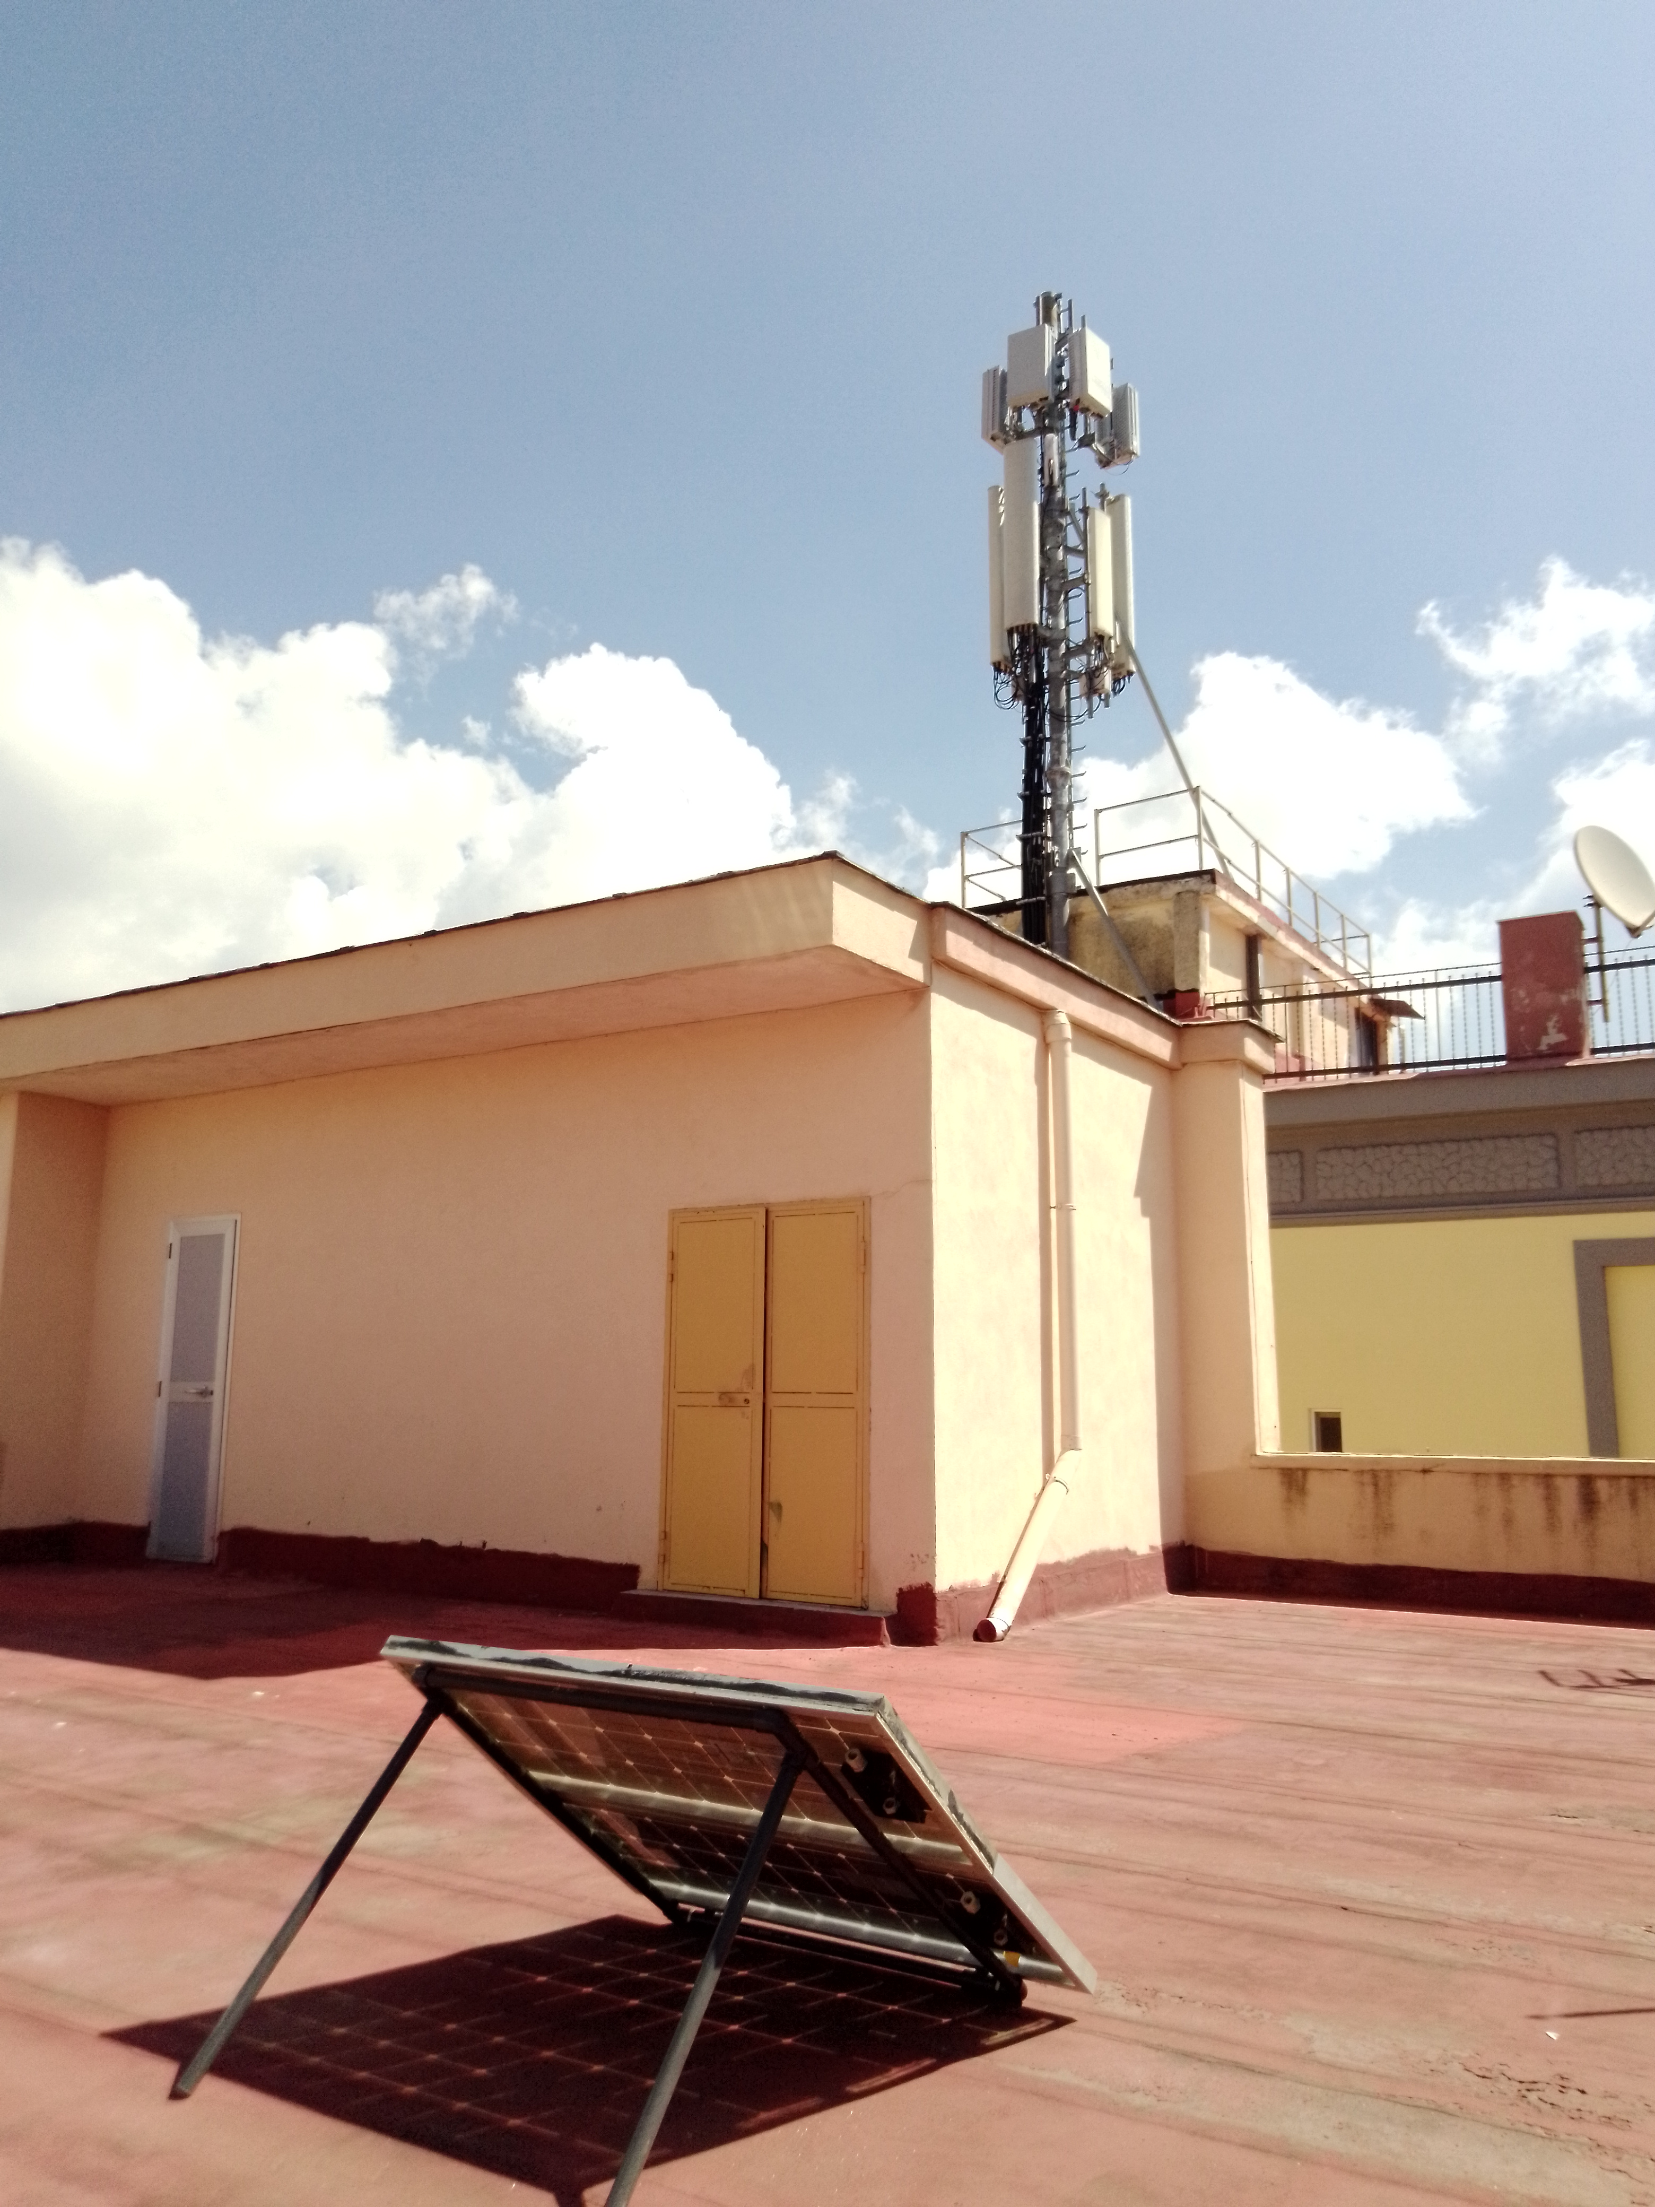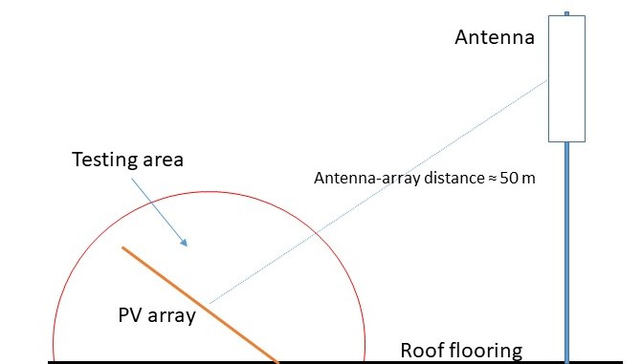
- b)
Figure 4: a) The photovoltaic array under testing placed on a roof next to the mobile antenna, at a distance of about 50 m and towards that oriented; b) a schematic of the experimental set-up.

The effect of the small PV array on the EM wave propagation has been measured by means of the electromagnetic field meter PCE Instruments PCE 29A, characterized by an operating range from 50 MHz to 3.5 GHz and also evaluated in terms of specific transmission in the 4G range by evaluating the intensity of the radiation emitted by means of the Network Cell Info Lite application (Okandeji, 2021). EM measurements (without the array ) have been performed in a selected area (where the array would have been then placed) and at the backside of the array (with the array ) once it has been installed in the selected area. In Table 1 the average EM field values measured by means of the PCE 29A meter and the relative intensity values in dB measured using the Network Cell Info Lite application, are reported.

Table 1: Electric field intensity and its relative variation with and without the PV array.
 | With the array | Without the array |  | With the array | Without the array
Electric Field  (V/m) | 1 +/- 0.5 | 3 +/- 1 | NCIL (dB) | -57 | -51  (saturated)

It is worth to note that no major variation in the electric field values has been observed in measurements performed at different points at the backside of the array in spite of the difference between the back contact structures, shown in Figure 3b. An enhancement of the electric field up to 4.6 V/m +/- 1 V/m has been observed when measurements have been performed at several points of the front side of the array, at a distance of about 10 cm from that.

  - Discussion
Data in Table 1 show that the presence of the photovoltaic array significantly modifies the propagation of the RF waves emitted by the mobile antenna station, reducing their intensity by about 70%. As expected from the theory, from the point of view of EM waves propagation, the photovoltaic array behaves like an almost perfect reflector, shielding the building from the propagation of the EM waves. Such a shielding effect can be therefore considered effective in reducing health risks for people living in close proximity to mobile base stations. Furthermore, measurements performed on the front of the array show that the array effectively behaves like a passive reflector, behaving as a secondary EM wave source (Khawaja, 2019). As above recalled, passive reflectors that help the propagation of EM waves connected to RF transmission are receiving an increasing interest from the scientific community. Compared to techniques such as beam-forming and beam-steering using multiple antennas or the use of higher power antennas, passive reflectors exhibit the clear advantage of being more energy efficient, cheaper and characterized by greater use flexibility. Clearly since the photovoltaic array has a defined orientation in order to maximize the production of photovoltaic energy, the dual use as an EM reflector poses some limitation. For instance, if we consider, in the Italian case, a 100 m² roof covering 4 apartments, the required photovoltaic coverage should be around 50 m², about half of the roof. In general the N-S orientation is actually preferred but, if EM shielding and RF reflection are considered, maybe also the E-W direction could be selected as a possible option since, from the point of view of energy production, there is no great difference between the two orientations, at least at certain latitudes (Mertens, 2019). Moreover using different panel design such as bifacial panels, since the power density increases, different and innovative installation structures could be also considered that help to consider EM waves propagation into plant design.
In this respect also the solar cell structure could be more carefully engineered. The metal that performs the effective function of reflector at the rear contact of the solar cell could be for instance processed in such a way as to make it either an anisotropic diffuser, or even to allow the filtering of specific transmission frequencies (Fallahi, 2008). The photovoltaic cell would thus acquire a further function in the ICT environment, without losing any property in terms of energy conversion.

  - Conclusions
Building roofs and facades are supposed to play an important role in the energy transition frame as they offer wide areas for the installation of photovoltaic arrays. On the other hand, as it has been above discussed, photovoltaic modules interfere with EM propagation as they can limit or enhance EM diffusion. In this paper it has been shown that photovoltaic arrays can exhibit EM shielding properties in the GHz range and are capable to modify the propagation of RF waves connected to 4G, 5G or even 6G technologies. This shielding property can be therefore exploited to limit the deleterious effects that mobile base stations operation shows on human health. Since photovoltaic arrays exhibit, at the same time, a relevant EM reflectance, they can be also used to modify radio waves propagation and, in a future scenario, they could integrate into the ICT environment in order to allow a more uniform and controlled propagation of the RF signals. Finally, recalling, as above reported, that appropriate solar cell design can make a RF antenna of a solar cell, there is a wide space for R&D in order to integrate these two sectors.

Acknowledgments
Thanks are due to Mr Antonio Citarella and Mr Francesco Verde for their technical assistance in the experimental set-up preparation.

References
Baccouch C., Sakli H., 2019, Design-of-a-Compact-Meshed-Antennas-for-5G-Communication-Systems, World Academy of Science, Engineering and Technology, International Journal of Electronics and Communication Engineering, Vol:13, No:11.
Balmori A., 2022, Evidence for a health risk by RF on humans living around mobile phone base stations: From
radiofrequency sickness to cancer, Environmental Research, Volume 214, Part 2.
Born M., Wolf E., 1953, Principles of Optics, Pergamon Press, cap. 13 p.622.
Fallahi A., Mishrikey M., Hafner C., Vahldieck R., 2008, Efficient Procedures for the Optimization of Frequency
Selective Surfaces, IEEE Transactions on Antennas and Propagation, Vol. 56, n. 5
Khawaja W. A. G., Ozdemir O., Erden F., Guvenc I., Ezuma M., Kakishima Y., 2019, Effect of Passive Reflectors for Enhancing Coverage of 28 GHz mmWave Systems in an Outdoor Setting, 2019 IEEE Radio and Wireless Symposium (RWS), Orlando, FL, USA, 2019, pp. 1-4, doi:10.1109/RWS.2019.8714266.
Mertens K., 2019 Photovoltaics, 2nd ed., Wiley., cap. 2
Namin A., Chenvidhya D., Thongpron J., Jivacate C., 2013, Dynamic characterization of solar cell using intensity modulation transfer impedance spectroscopy, the 23rd International Photovoltaic Science and Engineering Conference, The Taipei International Conventional Center (TICC), Taipei, Taiwan, Volume: Oct.31, Poster Sessions, Area 6.
Okandeji A., Onaifo A., Alajide M., Okubanjo A., Fasanya H., 2021, Analysis of mobile telecommunication path loss in rural communities, Journal of Engineering Studies and Research, 26(4), 69-73. https://doi.org/10.29081/jesr.v26i4.238.
Solar Power Europe, 2023, European Parliament votes in favour of Solar Rooftops https://www.solarpowereurope.org/press-releases/statement-european-parliament-votes-in-favour-of-solar rooftops-2; accessed 30.03.2023.

